8.108: The impulse applied to the cake is 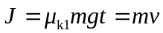, where m is the mass of the cake and v is its speed after the impulse is applied. The distance d that the cake moves during this time is then 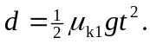 While sliding on the table, the cake must lose its kinetic energy to friction, or 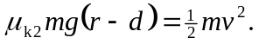Simplification and substitution for v gives 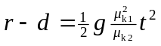, substituting for d in terms of 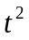 gives

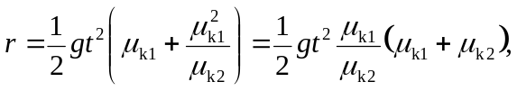
which gives t = 0.59 s.

